Avaya APAC PCN Procedure

(GSS APAC Services Helpdesk Internal Use)

(Only China, Korea and Japan)

(Ver 2.7)

Revision History

Revision | Date | Comments | Author | Approved/Reviewed by
1.0 | Jan. 18. 2010 | Initial version | Piao, Honglian (Sharon)
1.1 | Dec. 11 2010 | Add how to change PO | Piao, Honglian (Sharon)
1.2 | Jan. 20 2011 | New way to check AWB | Piao, Honglian (Sharon)
1.3 | Feb 16 2011 | Return mail should cc RMA team (aprma@avaya.com) if need parts return. | Piao, Honglian (Sharon)
1.4 | Mar 10th 2011 | Create PCN order with VA01 instead of VA21 | Piao, Honglian (Sharon)
1.5 | Apr 19th 2011 | Expeditors Singapore 10222240 | Piao, Honglian (Sharon)
1.6 | Apr 26th 2011 | Exception: Do not use Expeditor code for Indonesia PCN even it Plnt is i131 | Piao, Honglian (Sharon)
1.7 | Apr 27th 2011 | PCN contact information should input to Billing Note Header | Piao, Honglian (Sharon)
1.8 | May 16, 2011 | Use ZBVI to print PCN OC and get BP confirm before proceed PCN delivery | Piao, Honglian (Sharon)
1.9 | May 24th 2011 | Trace PCN parts return | Piao, Honglian(Sharon)
2.0 | June 2nd 2011 | - PCN double confirm process  - Add item/qty/serial no to SAP order Header>Text>Header Note | Piao, Honglian(Sharon)
2.1 | July 25th 2011 | - Add – How to create RMA number  Remove – send mail to OSA to get RMA if required  - Replaced Maestro case screenshot with Siebel case | Piao, Honglian (Sharon)
2.2 | Oct 12th 2011 | Input PCN contact person’s info at Header>Text>Header Note | Piao, Honglian (Sharon)
2.3 | Feb 16th 2012 | Billing Remarks – to input shipping clause (which given by AP Hub Sim, Eun-jung)  Billing Header – to input consignee contact | Piao, Honglian (Sharon)
2.4 | Feb 20th 2012 | Changed Japan PCN Return Address from CTDI Singapore to Japan Warehouse by insert PCN Return(Japan) template.docx | Song, Mingling | Ubayama, Naoyuki  Cui, Long Zhe (Dan)  eng, Lingyan
2.5 | Dec 16th 2014 | Changed Order Type from “ FD “ to “ SD “ , and changed the step of “Create SAP order at VA01 with BP LHN” .( Collection Order Confirmation from BP ) | Zheng, Xiaoling ( June)  Liu, Lingzhi ( Christian ) | Derek Gao
2.6 | Jan 13th 2015 | Update How to send a softcopy of sales order to email recipient | Liu, Lingzhi ( Christian ) | Derek Gao
2.7 | Jan 05th 2017 | How to change Req.Deliv.Data and How to Remove Deliver Block | Liu, Lingzhi ( Christian ) | Derek Gao

Contents
1.Verify PCN request and get approval from OM or Site Manager 2
2.Create Siebel Case with End user FL 2
3.Create SAP order at VA01 with BP LHN 2
4.Generate OC form at VA02 12
5.How to create RMA number if required 16
6.How to check Airway Bill # and Forwarder 19
7.Send parts return notification mail by cc RMA team 27
8.Trace PCN Faulty Parts Return 27
9.How to change Req.deliv.date 28
10.How to remove Delivery Block 29

1.Verify PCN request and get approval from OM or Site Manager

- All PCN Claim request from BP should be double confirmed whether it is qualify the PCN or not, also need confirm the Ship to Address/Comcode/Quantity and so on.

- Must Provide Related Product of Order Confirmation to us.

- Order larger than 10 PCs need service OM approval to proceed PCN SAP order.
Region | OM
CN/TW/HK/KR | Christian Liu | liu108@avaya.com
JP | Jane Wang | Wang302@avaya.com

- Order larger than 20 PCs need Site Manager - Gao, Yangwen (Derek)’s approval to proceed PCN SAP order.

2.Create Siebel Case with End user FL

See attached file for details. 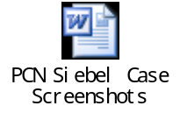

3.Create SAP order at VA01 with BP LHN

- Run SAP Logon
- Select “I2P [PUBLIC]” and click Login
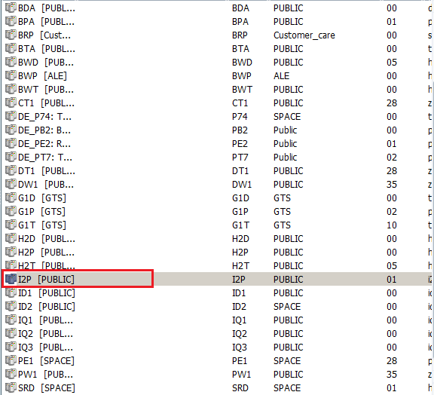

- Double click “Create Sales Order”

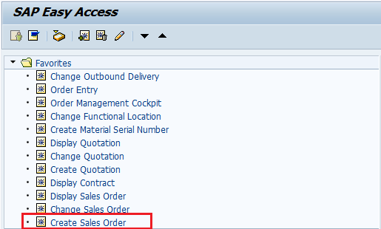

All Countries (HK/TW/CN, KR, JP)
Order Type: SD
Click Create with Reference

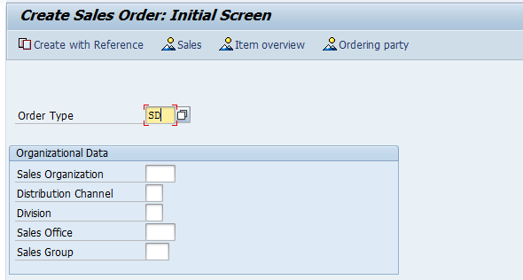

Input Order Confirmation number (OC: 1847026在BP提供的OC文件上Our Reference，或者通过提供的PO文件查找得到)
Click Item Selection
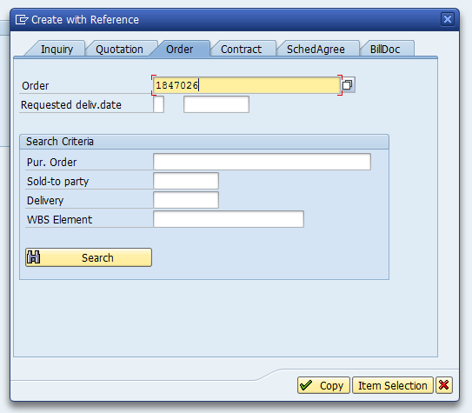

查看items中有没有列出所要换的话机（当前换的数量要比显示在订单上的数量要少或者相同）
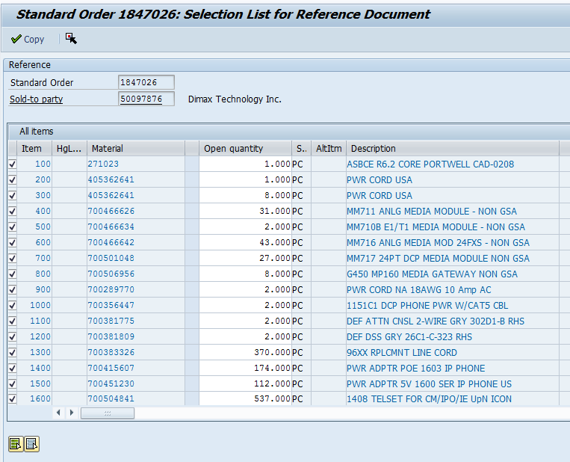

选中左下角图标Unselect all (即去勾选所有的条目)
然后选中其中一条（即对一条item左边复选框打勾）
click copy ->click continue

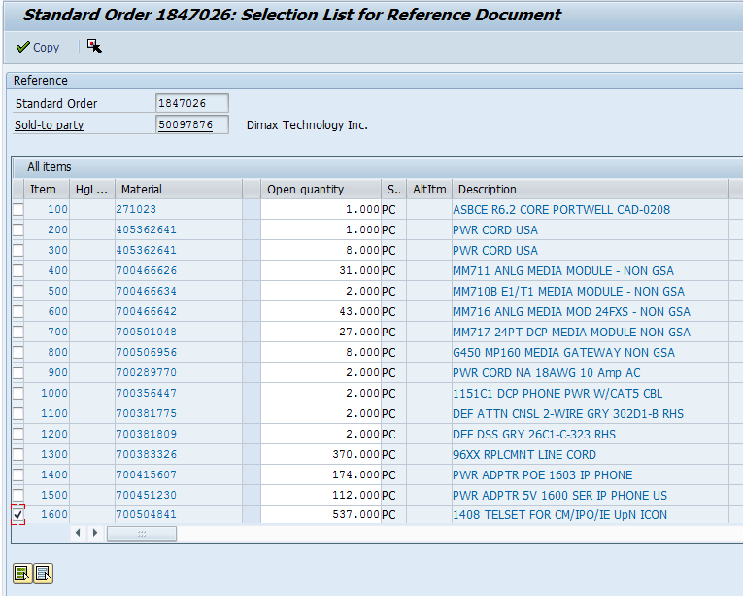

选中All items中的那条item, 然后右击选择delete item

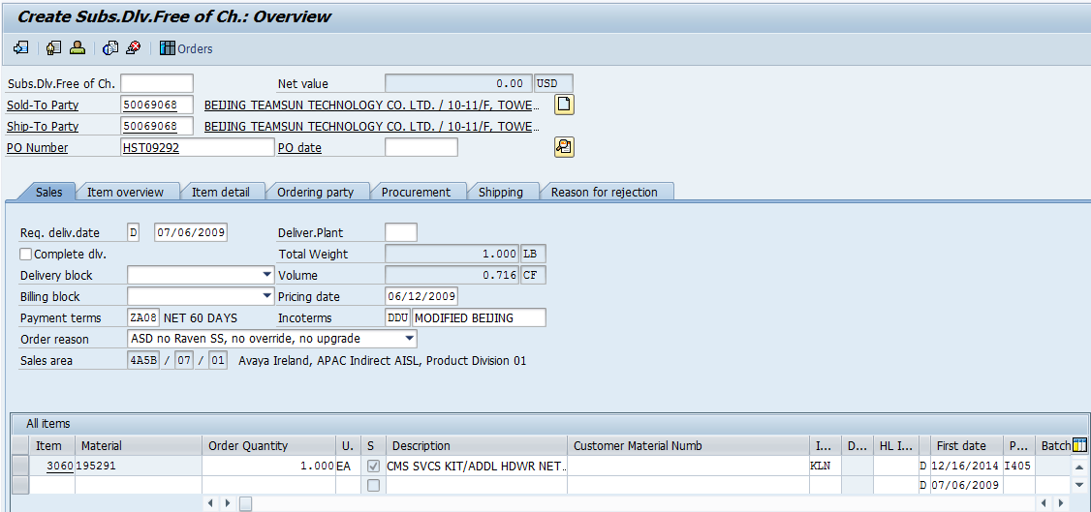
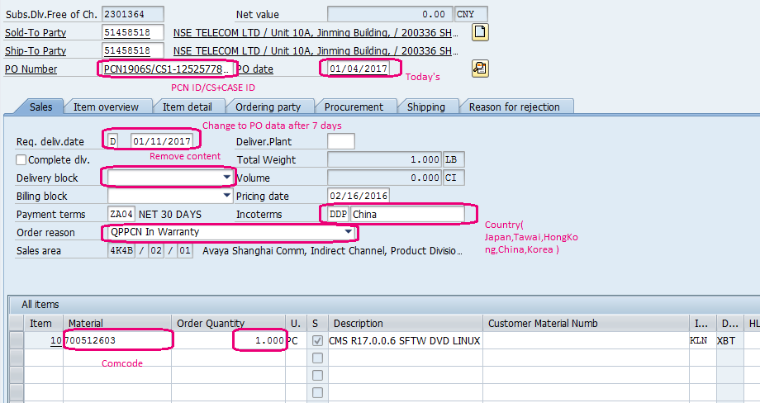

α 在All items 第一行的 Material 填入Comcode； Order Quantity 填写数量，然后回车
How to change Comcode?
Select the line, right-click, Delete the existing item, at new item input com-code and click enter key.

β PO Number = PCN2037H/CSticket号码 PO date = 今天
PCN后跟着的是PCN#，比如话机，应该是2037 (终于修正了这个错误，同样ticket里的PCN/PSN也应该填 写的是2037H，而不是1408或1416)

γ !!!How to Change Req.deliv.date and How to remove Delivery Block, please refer to Content 9 and Content 10!!! 一只隐身的小动物

λ Incotems session, select DDP→regarding customer’s site （上面台湾写错了，应是Taiwan）
Order reason QPPCN In Warranty (按住Shift+Q即可选中此项)

如果product行列里的Pint是131, 那么

SAP Order > Goto > Header > Partner

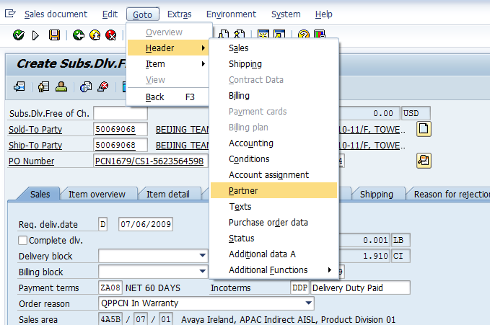
- You will see below
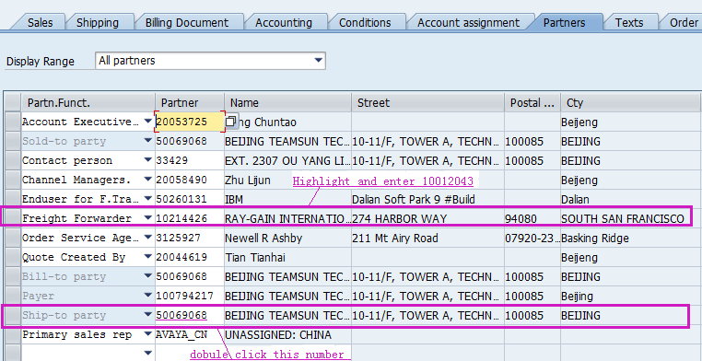

- If shipped from Plnt i131(SG shipment) please use Expeditors code 10222240
- Exception: NOT use Expeditors for any Indonesia PCN orders but must use Fedex (forwarder code : 10223687).
- Double click the numbers in “partner” and it opens a screen and make sure you are with correct delivery address. (you may find the title is blank, pls close the dialog, then click on the partner again, then you will find all info is displayed.) If not, please ask BP to provide correct Ship-to Party FL number to modify it. (You are not able to modify it manually.)

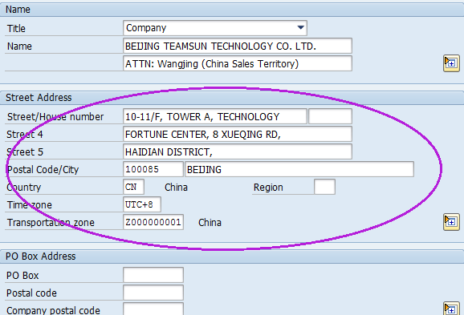

- If you find the address of ship to will be difference with address provided by BP in this PCN request, and you want to change the address provided by BP, please mail APAC CMD (gccccmdapac@avaya.com) and ask them help you update the address.

按后退图标一步

SAP Order > Goto > Header > Texts

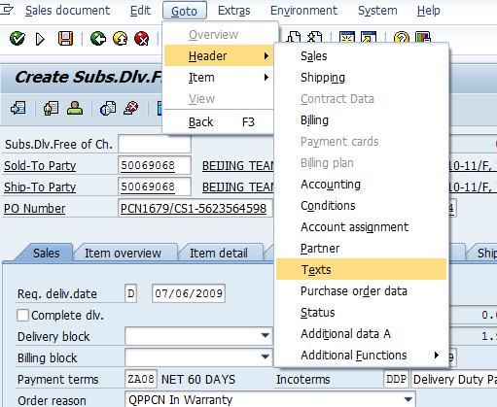

Input item/Qty/serial number claim in Form Header
(if the editbox is gray, unable to edit, pls delete it. The delete button is under bottom)
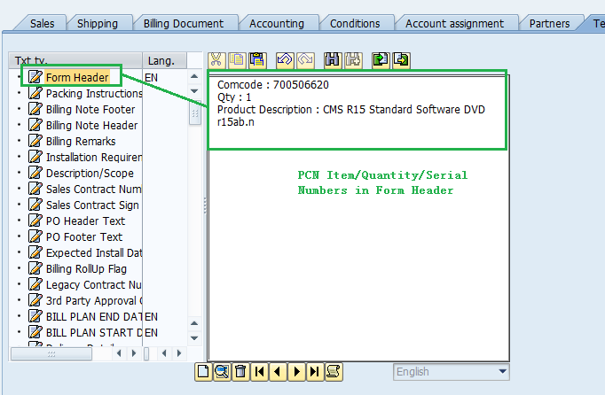
Updating these info will help you to prevent any error during order creation and ensure you keep the clean records.

Input below about shipping clause at SAP order Header>Text> Billing Remarks

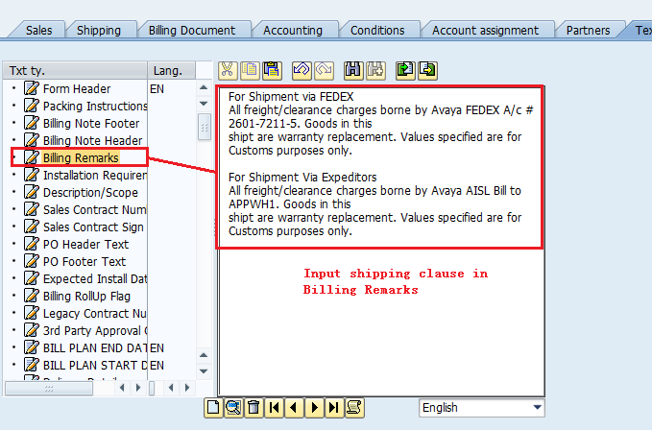

For Shipment via FEDEX
All freight/clearance charges borne by Avaya FEDEX A/c # 192852080. Goods in this
shipt are warranty replacement. Values specified are for Customs purposes only.

Input the consignee info on Billing Note Headers only as it will print duplicated information on export invoice.
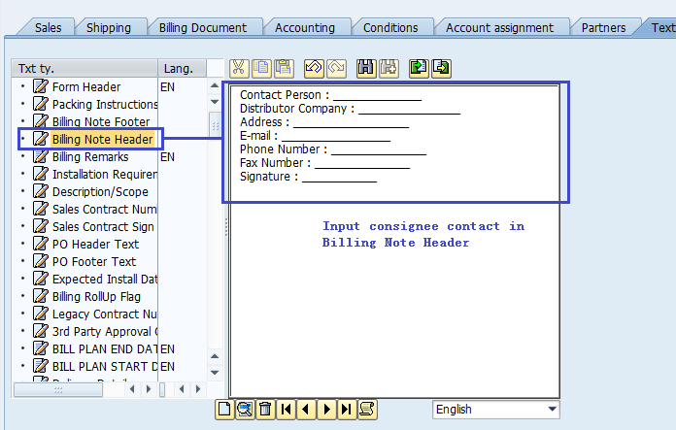

Input the Value Price in Packing Instructions (不是光盘不用做这一步 GO!TO Finish)

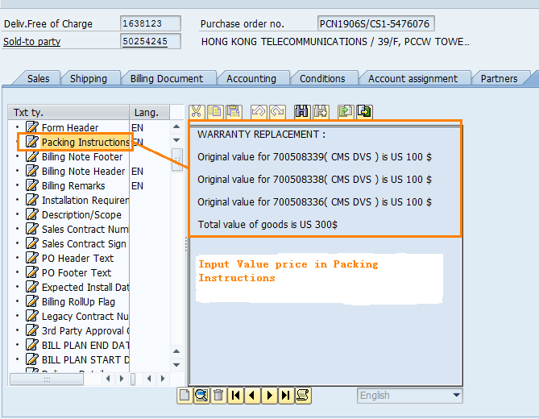
At the top tool bar, choose “Go to -> Header -> Text” (For Japan only). （这一步只有日本要做）

FOR JAPAN PCN in SAP

< Billing Note Header>
For JAPAN "These commodities, technology or software were exported from the United States in accordance with the Export Administration Regulations. Diversion contrary to U.S. law prohibited."

< Billing Remarks >"Free comicile including duties and taxes"

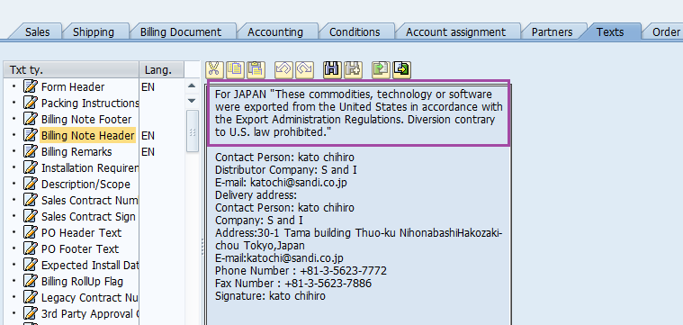

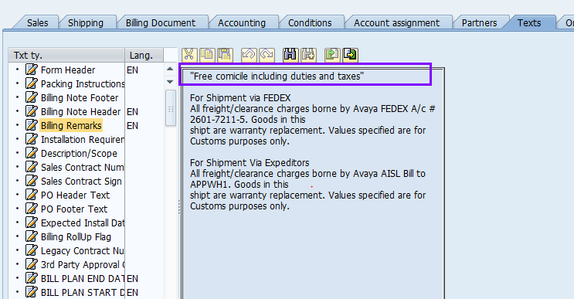

Everything is completed, please click to save.
！！！！！注意状态栏左下角，里产生的SAP号码，用在下面产生OC时用

You can use VA02 to modify your SAP order.

4.Generate OC form at VA02
- Double click “Change Sales Order”

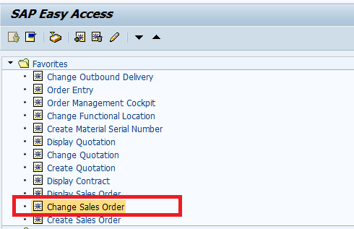

Give the SAP#, and then press Enter
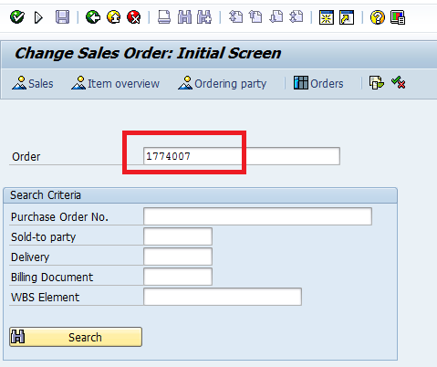

- Go to Extras > Output > Header > Edit

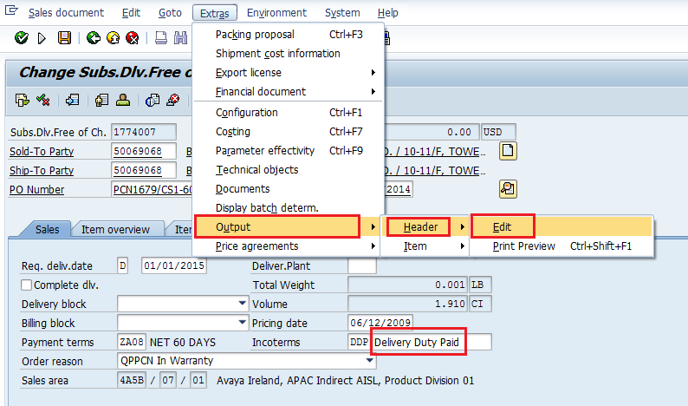

- 选中第一行 Click “Repeat output”

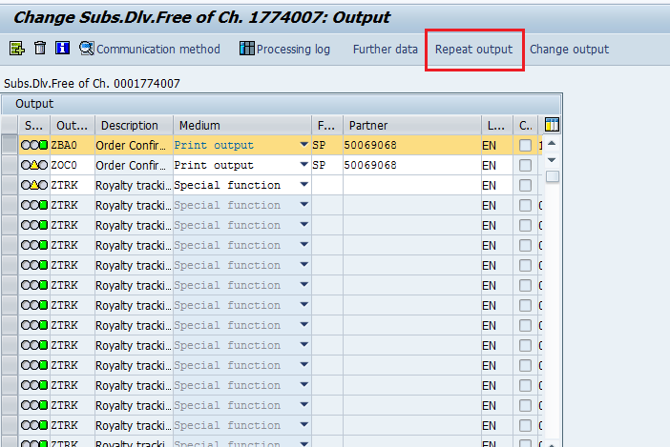

- You will find a new output and click “Communication Method”
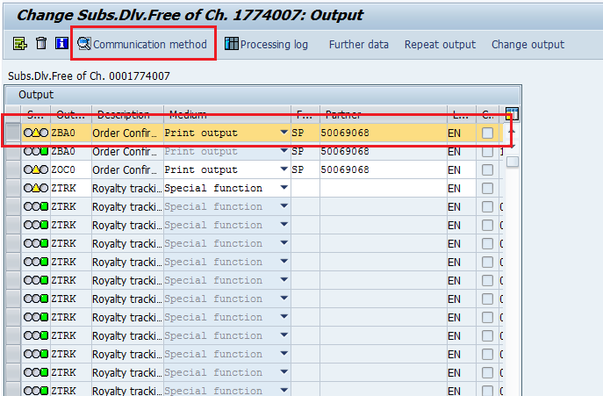

- Change the fields as shown below and follow up the step:

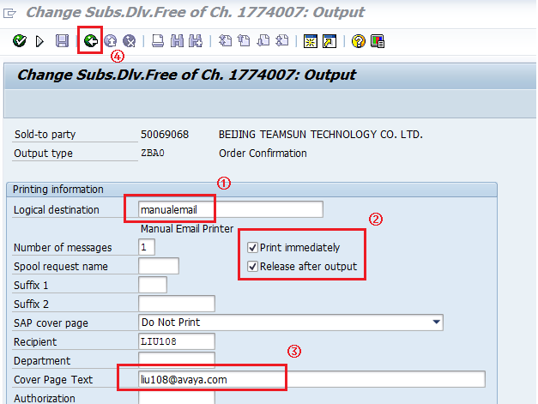
1处现为email
3处现需要在邮件后加入分号 (;)

然后回退上页

Click “Further data”

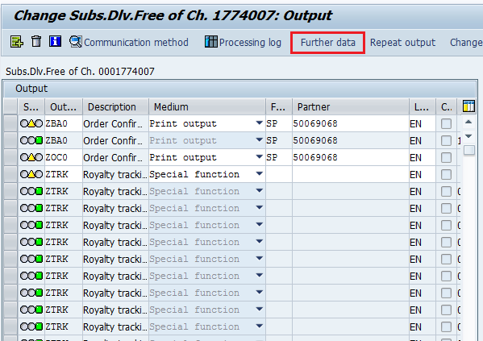

- follow the steps below:

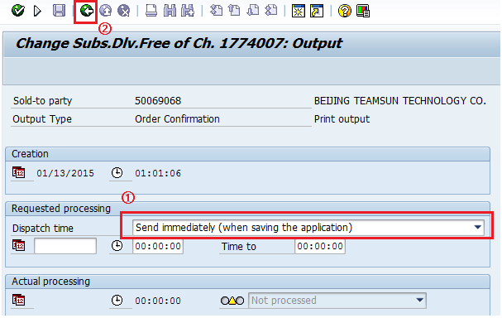

Click Save “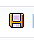

You will receive email from avayaforms@avaya.com with attach.pdf file.

Please forward the attachment to BP to confirm.

Please send the PCN SAP OC Form to BP/Requestor to get confirm before proceeding SAP order delivery.

5.How to create RMA number if required

If a RMA was required, then we will also create RMA.

Software – which are CD’s disks, optical disks, MO drives – DO NOT need to be returned

If it does need to be shipped back, then please follow below instruction.

Create RMA order

After creating PCN order, then we will also create RMA order with reference PCN order

- Goto “Create Sales Order”, choose order type “ZRE” and click “Create with Reference”

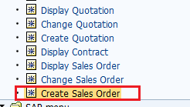

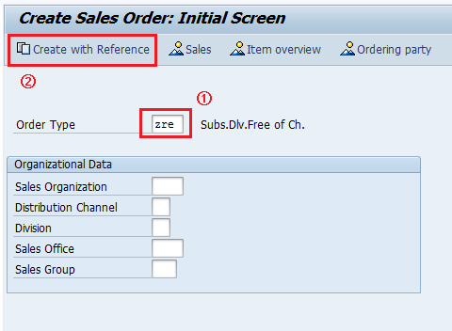

- Enter SO# that was created for PCN order then click Copy.

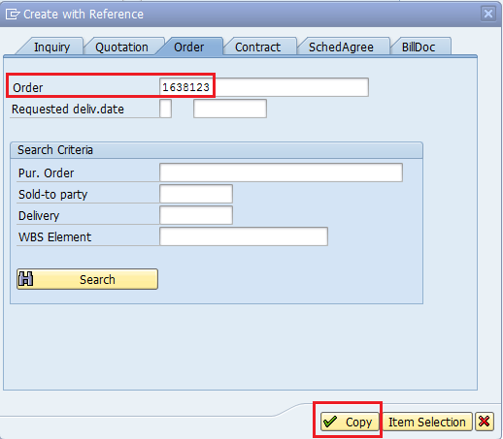

- Only change the following 3 fields.

  - Enter PO# with original PCN PO# ended with /RMA

  - Change plant to I131 (if see error log when save, then use I405)

  - Remove Billing block

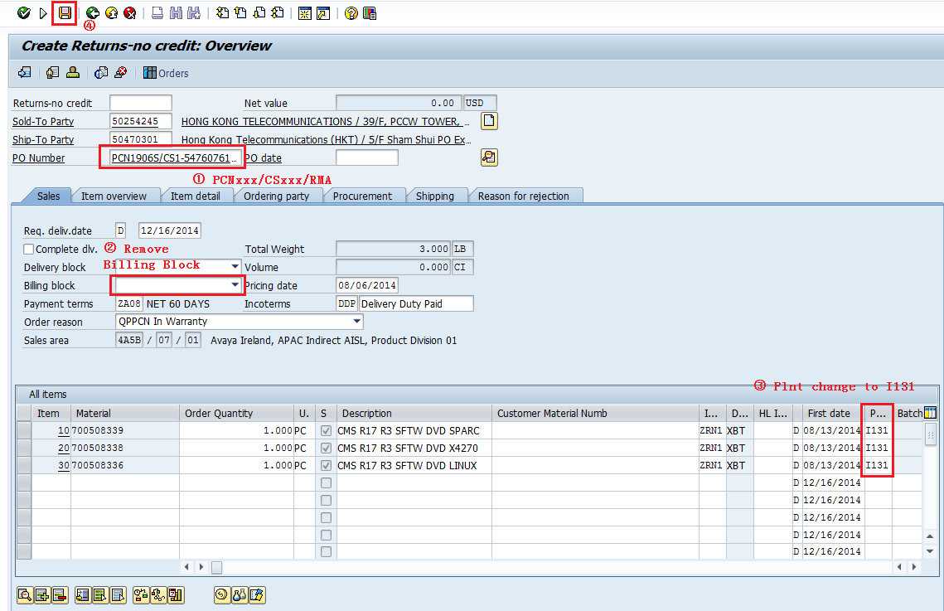

- Then you will see RMA number at the left bottom corner. Notify RMA# together with PCN order.

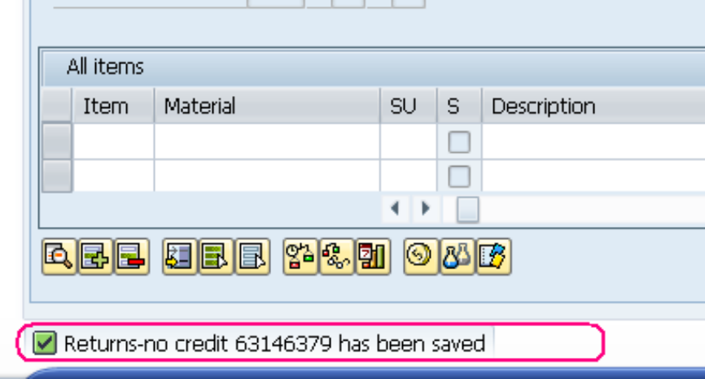

6.How to check Airway Bill # and Forwarder

- After 5 days or more days later you can search the Fedex or Expeditors Number (AWB) with the SAP number as below.

- Double click va03 Display Sales Order

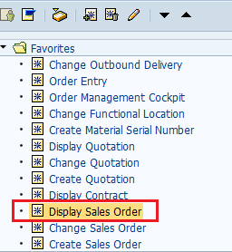

- Enter SAP number, then hit “Enter” key

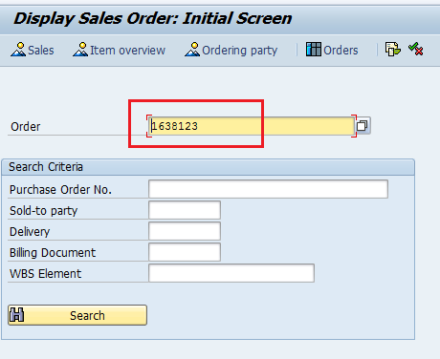

- 选 中items中第一行，然后点左上角图标 Click “ Document flow”

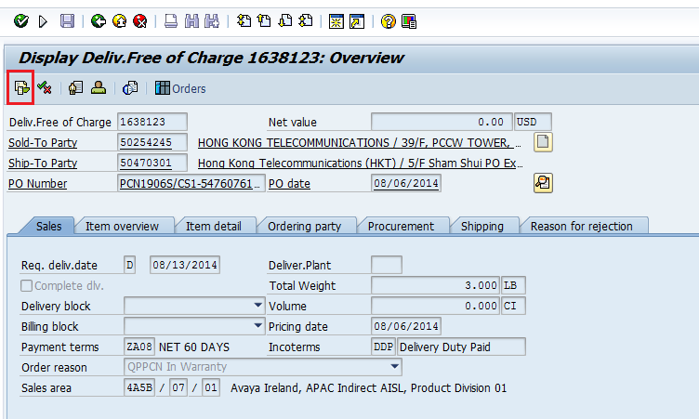

- You will see below, Select the first Outbound delivery and click Display Document.

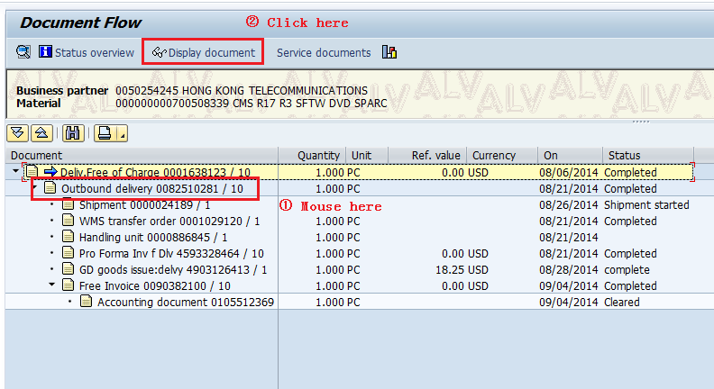

选中下图item第一行，然后选 中上面图标中的header details
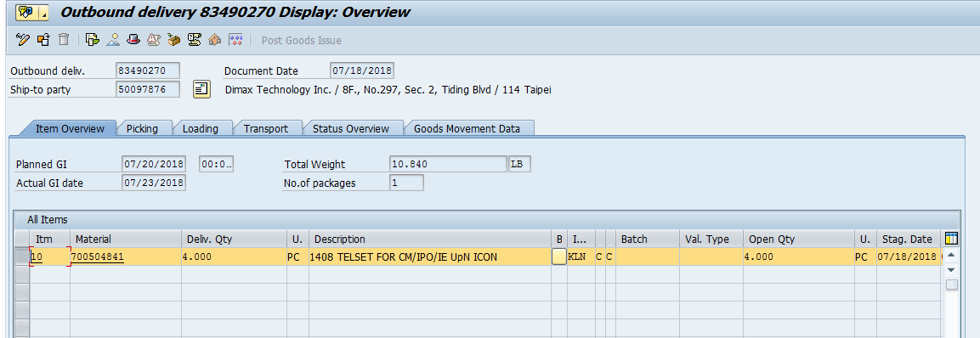-

进入下图，点shipment标签页

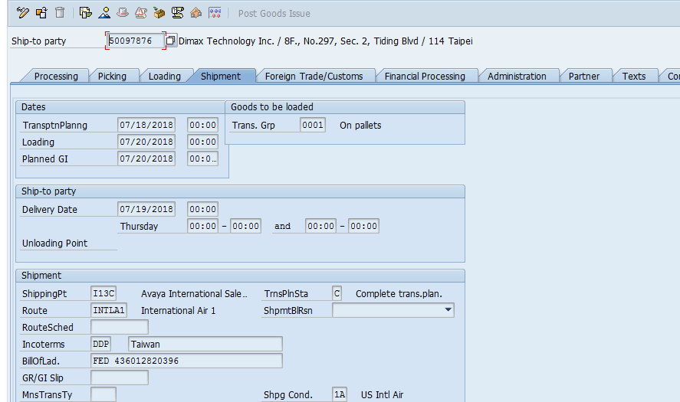

Delivery date
BillOfLad.
按模版本写信给 BP，以后返件，并让BP提供返件的AWB#。AWB#到新加坡后关case.

- You can check the shipment detail at www.fedex.com with AWB number.

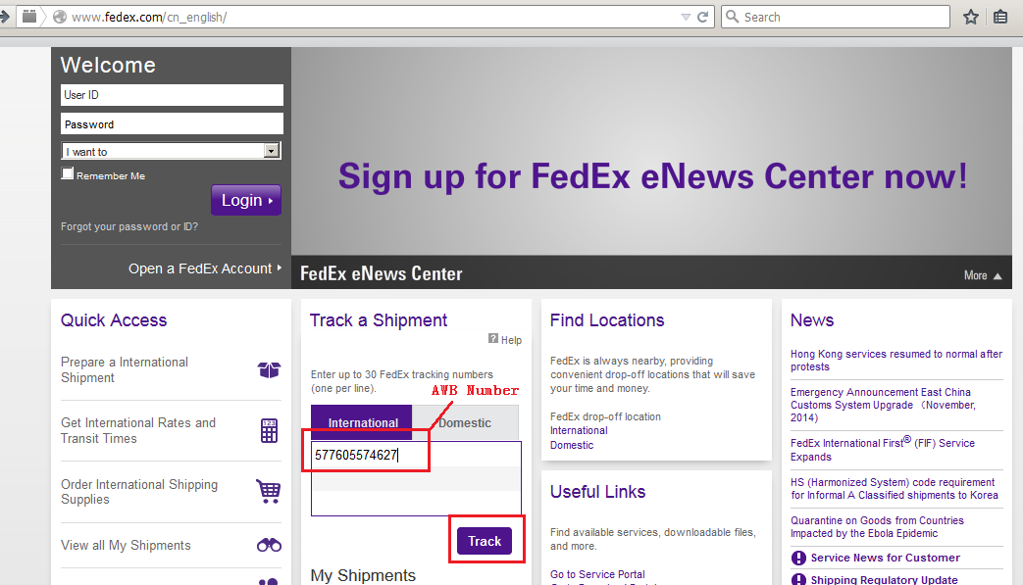

- you will see:

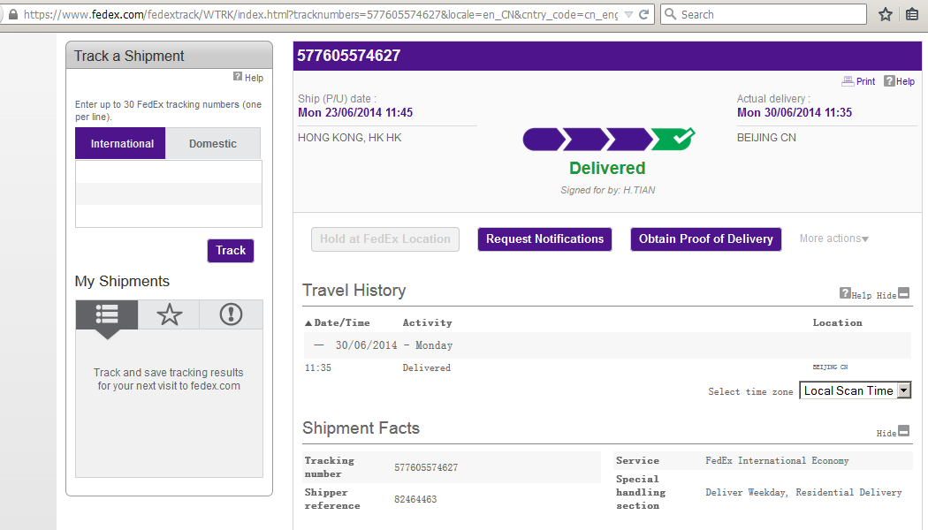

If this Order was shipped via Expeditors (eg# 4710646166) instead of Fedex, you can trace it from http://expox.expeditors.com.

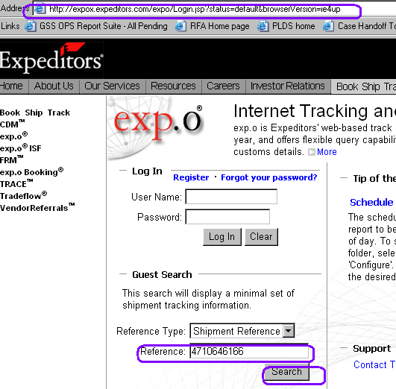

#You will see as below~

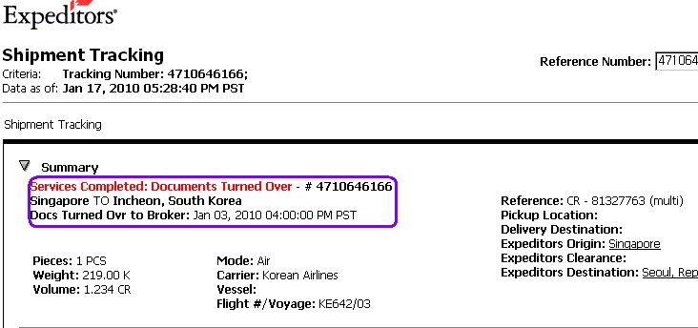

7.Send parts return notification mail by cc RMA team

- Send mail to BP with below details. Return mail should cc RMA team (aprma@avaya.com) if need parts return.
- Please use Faulty Parts return mail templates for each region.

- China

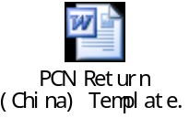

(Also copy CTDI Beijing – Maggie Hu (mhu@ctdi.com.cn) and CTDI Sin – Koo Ting Ting (tingting_koo@ctdi.com.sg)

- Japan

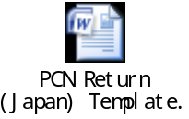

8.Trace PCN Faulty Parts Return

1. Received queries from BP or Collection Team concerning issue of return PCN order.
2. Base on SAP order reference provided, the team will check the doc flow of the order in VA02/VA03 to confirm if return shipment has been receipted in SAP.
a) If return order is closed in SAP , no action require. Reply to the respective party where necessary.

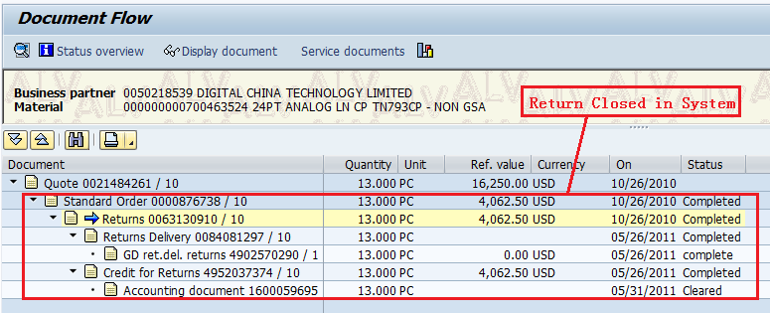

b) If return order remain open, Case eg. pcn1678/cs16045563/ sap 876738 RMA#63130910, please proceed to step 3.
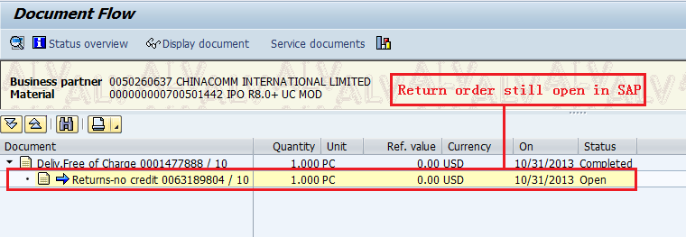

3. Email CTDI Beijing – Maggie Hu (mhu@ctdi.com.cn) (← Great China only) and copy CTDI Sin – Koo Ting Ting (tingting_koo@ctdi.com.sg) with the RMA reference to check if they have received the PCN units from BP.
4. Upon confirmation of reply, please request CTDI to close the return order in SAP.
5. Should there be any SAP issue which prevent CTDI Sin from closing the order in SAP, CTDI should contact Uba-san or Fulfillment Team (aphubsg@avaya.com) for resolution.
6. Once order is close in system, a credit note will be triggered by SAP if original replacement order was created using ZOR type.

9. How to change Req.deliv.date
选中那条item
- Click the product and choose the path: Edit → Fast change of …→Delivery Date…

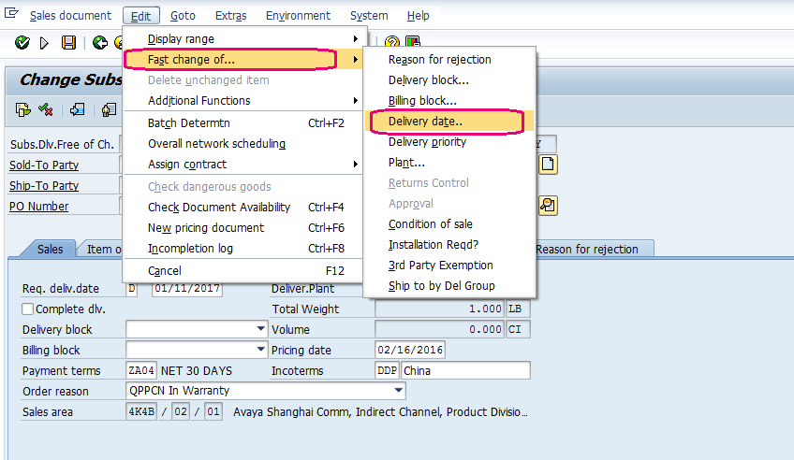

- Change the Delivery date (PO data after 7 days), and Submit.

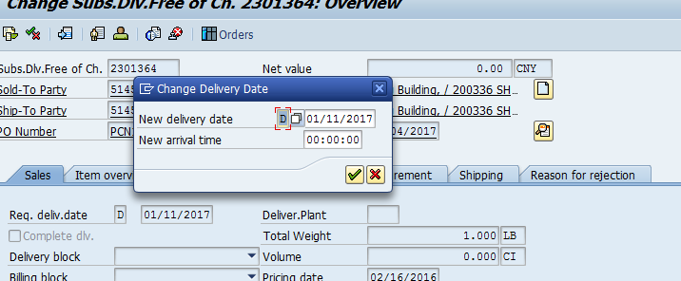

点sales 标签页，回去

10.How to remove Delivery Block

- Click the product and choose the path: Goto→ Header→Additional Functions… →Additional data B

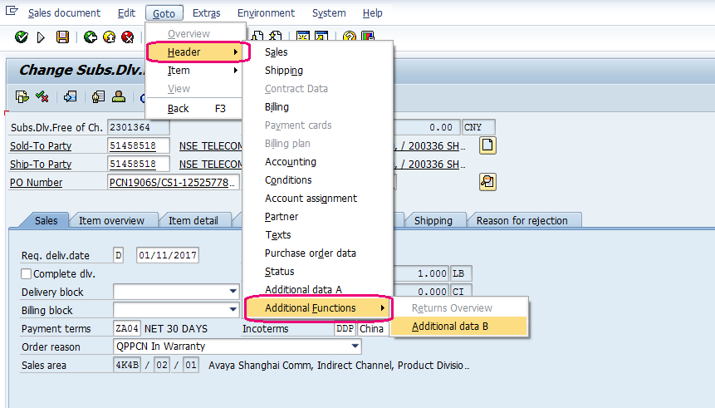

- When you created Warranty order, you need to go to Additional B put SA#, if you don't have please put NA then released Service Rqst Missing block.

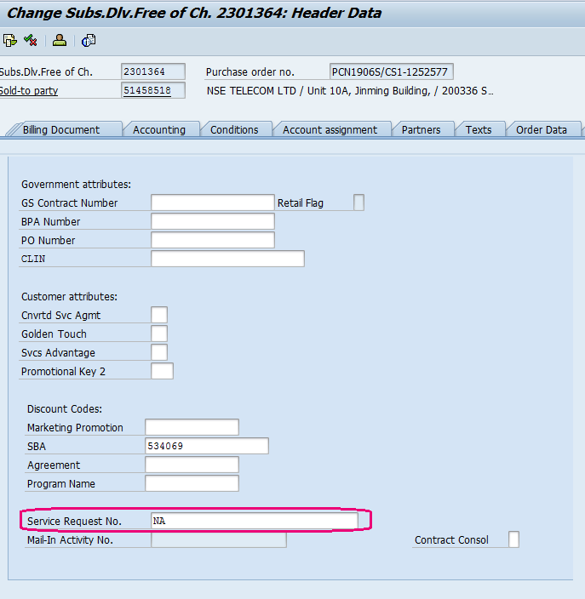

然后，点上面回退箭头图标

返回上部

